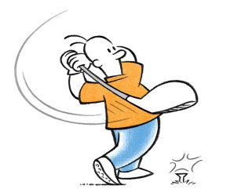Newark RUFC Golf Society
GOLF DAY
Supporting All Saints Church Coddington
The Brain Tumour Cancer Charity
Competing for the Hugh Daybell Trophy
+ Holders – Tim Barker & Alasdair Morrison+
Newark GC
Wed. 4th Oct. 2017
Any Combination Pairs BB Stableford Competition.
Max Handicap Gents 24 x ¾; Ladies 36 x ¾
+ Coffee & Bacon Bap on arrival + 2-course meal
+ Shotgun start 10.00am +
Entry fee only £75 per pair all inclusive
Player 1: .............................. Player 2: ................................
Email address: ……………………………….......
Donation: £……. Sponsored hole @ £25: …….. Prize : ……………………………
Entry form to Paul Strudwick + cheque payable to Paul Strudwick
BACS 40 34 08 41545256
7 Bentinck Road. Newark NG24 4HT
Paul.strudwick1@ntlworld.com
07974395165

