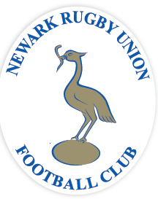

“Raise the Bar” Pledge Form

I have read and understand the loan scheme and am happy to express my interest in taking part
I feel I could contribute ……. units of £250 and confirm I have downloaded and viewed a copy of the loan agreement available from the link below.

Name: …………………………………………………………………………………………………………..
Address:…………………………………………………………………………………………………………
……………………………………………………………………………………………………………………
Email address:………………………………………………………………………………………………….
Telephone Numbers:…………………………………………………………………………………………………………

Download a copy of the Loan agreement HERE
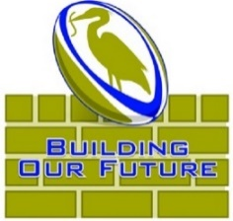
This “Pledge” form should be completed in full and then emailed as an attachment to
raisethebar@newarkrugby.com

