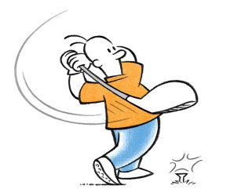Newark RUFC Golf Society
The 4th Hugh Daybell Golf Day.
Supporting
The Brain Tumour Cancer Charity & All Sts Church. Coddington
Competing for the Hugh Daybell Trophy
Newark GC
Wed. 2nd Oct. 2019
Any Combination Pairs BB Stableford Competition.
Max Handicap Gents 24 x ¾; Ladies 36 x ¾
Coffee & Bacon Bap on arrival + 2-course meal to follow
+ Shotgun start 10.00am +

Entry fee only £80 per pair all inclusive.
Other support most welcome:
Sponsored hole @ £25: …….. Prize/Donation: …………………….
Player 1: .............................. Player 2: ................................
Email address: ……………………………….......
Entry form to Paul Strudwick + cheque payable to Paul Strudwick
BACS 40 34 08 41545256
7 Bentinck Road. Newark NG24 4HT
Paul.strudwick1@ntlworld.com 07974395165

